**LAMPIRAN C**

**SURAT BALASAN**

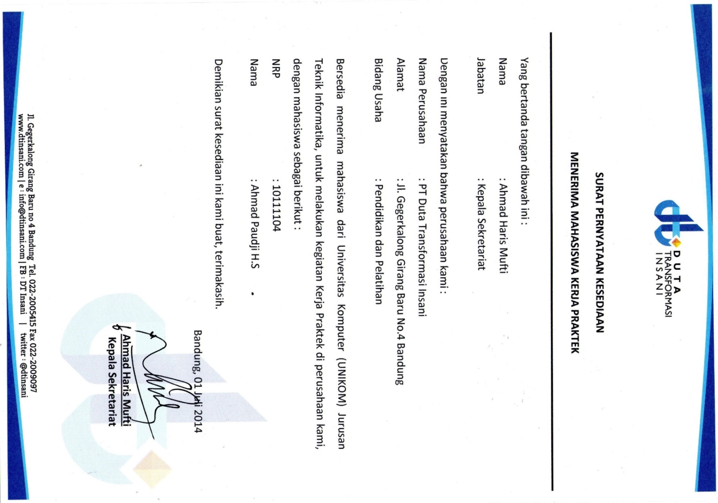

**Gambar 7 Surat Balasan Ahmad Paudji H.S**